Final Project

## Intro

* Hvordan har jeg tænkt mig at løse opgaven
  + Lav en graf med de 20 lande for hvert år
    - År som x akse?
    - Drab/selvmord som y akse?
    - Hvad hedder disse data?
  + Ud fra grafen lave en vurdering ift. Sammenhængende mønster
  + Skriv alle data I RStudio
  + Check the rows
* Hvordan bliver ranglisten vurderet?
  + In the report one can read more detailed explanations on what variables the scores are based on, and what subjects have contributed to happiness or unhappiness for the different years.
  + Wikipedia: The rankings of national happiness are based on a Cantril ladder survey. Nationally representative samples of respondents are asked to think of a ladder, with the best possible life for them being a **10**, and the worst possible life being a 0. They are then asked to rate their own current lives on that 0 to 10 scale.
  + Based on the 3 previous years – forklar hvordan flere år er gundlag for placering
  + Variabler fra WHR -GDP mm.
    - 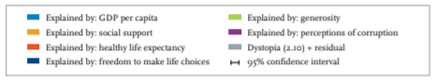
* Hvor finder jeg data?
  + Hvor har jeg fundet listerne?
    - Selve raporten
    - Vedhæftet data appendix
      * In the World Happiness Report 2015, the data file is called “*Statistical appendix*”.
      * In the World Happiness Report 2017, the data file is called “*Final data for Figures in Chapter 2*”.
    - Hvorfor vælger jeg den jeg har valgt
      * De kan altså findes to steder. Jeg bruger fra selve reporten idet det gav mest mening I forhold til hvordan jeg skulle bruge dataene.
  + Rows
    - Fandt rows efter at downloade HSR i RStudio, hvor jeg kunne åbne tabellen som jeg har kaldt rates, og søge efter lande I tabellen, og derefter finde de pågældene årstal og hvilket row nr. De har
  + I 2017 versionen er ladder score ændret til happiness score
    - Here the ranking of happiness is based off a happiness score.
* Hvilke data burger jeg og hvorfor?
  + I will look at the years 2013-2017, as the world happiness report started making???? In 2012 and the homicide?? Data ends in 2017
  + Ikke 2012 pga “In this section, we first present in Figure 2.3 the 2010–12 national averages for life evaluations, with each country’s average score divided into seven pieces.25 The overall ladder rankings differ from those in Figure 2.3 of the first World Happiness Report. First, they include more up-todate data, with the ending point of the new data coverage moving forward from mid-2011 to the end of 2012. Second, in last year’s report we averaged all available data, running from 2005 until mid-2011, while this year we present averages for the three years 2010-12, giving a sample size of 3,000 for most countries.26 We focus on the more recent data for two reasons. First, we expect that readers want the data presented in our key tables to be as current as possible, consistent with having sample sizes large enough to avoid too many ranking changes due to sampling fluctuations. Second, we want to be able to look for changes through time in the average happiness levels for countries, regions, and the world as a whole
  + Jeg burger HSR fra det år som WHR er udgivet I, ikke alle de år som er grundlag for landenes placering
* Problemer jeg er stødt på undervejs
  + Ikke lavet en WHR for 2014?
  + NA data I HSR
* Bilag
  + Hvad er der af bilag
    - Top/bottom countries
    - Hvorfor som bilag?
* Udvidelse af undersøgelse:
  + Hvis man vil udvide undersøgelsen kunne man også se på hvorfor lande stiger/falder på listen
    - Er der sket noget bestemt I det pågældende land? (krig, terror, sygdom, politik)
    - Eller er det I de lander der overhælder/falder I rang som der sker noget i?
    - Påvirker man eller bliver man påvirket?

# Diagrammer

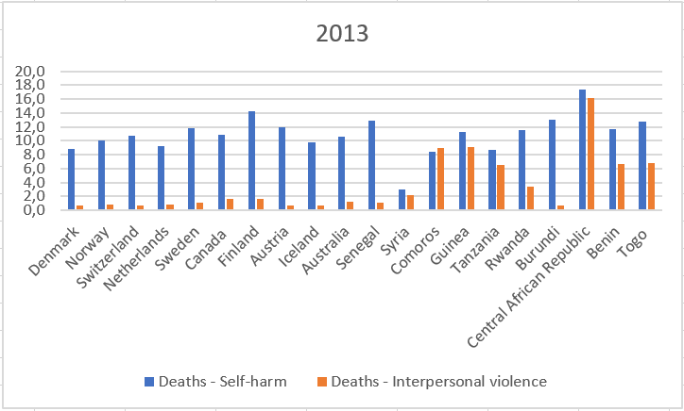

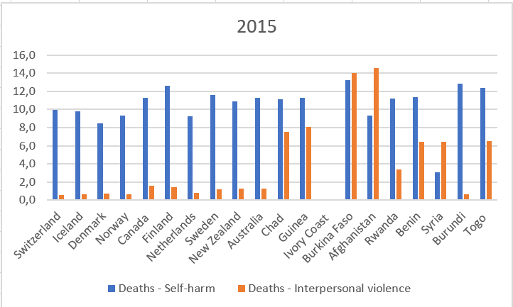

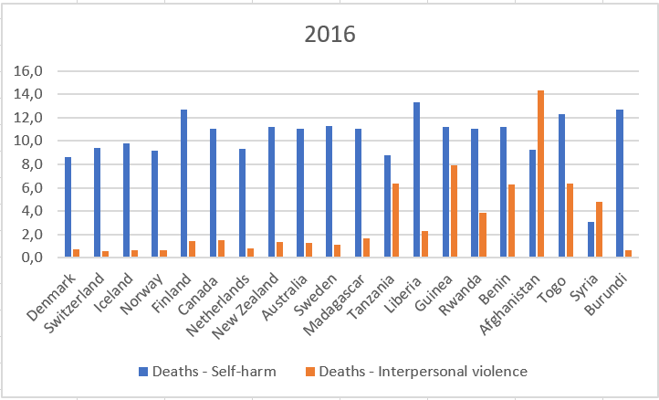

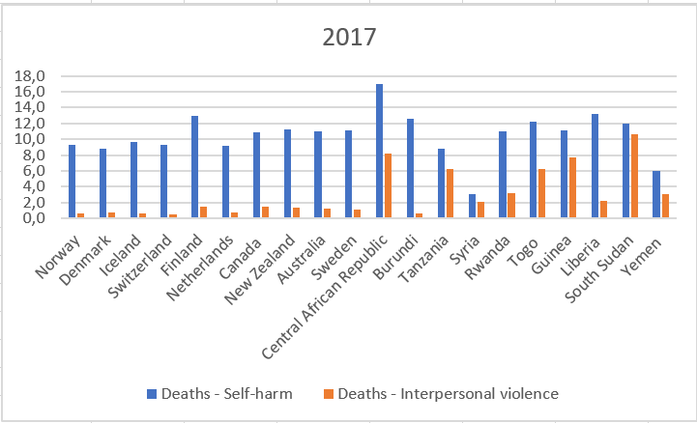

# Appendix

## Data from WHR

* Kort info om hvad der er inkluderet I billagene
  + On this figure the ladder score is also included.
* Find fodnoter på figurerne

### 2013 (2010-2012):

**Top 10[1]:**

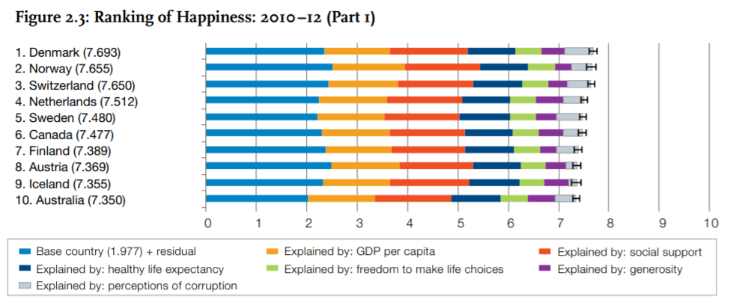

**Bottom 10[2]:**

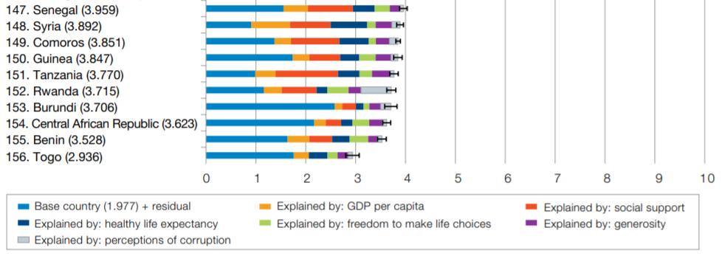

### 2015:

**Top 10[3]:**

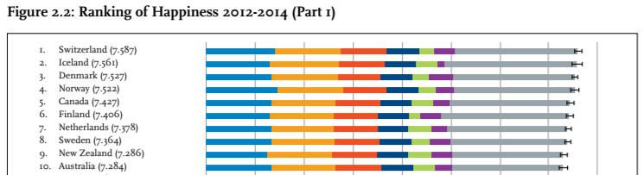





**Bottom 10[4]:**

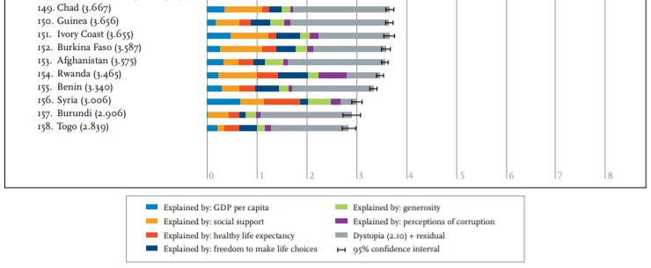

### 2016:

**Top 10[5]:**

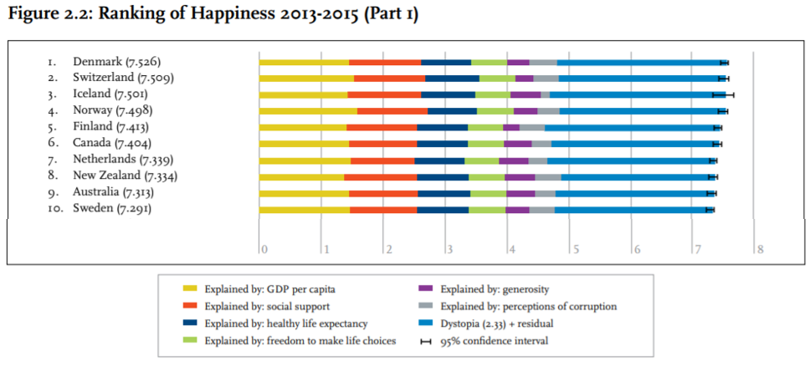

**Bottom 10[6]:**

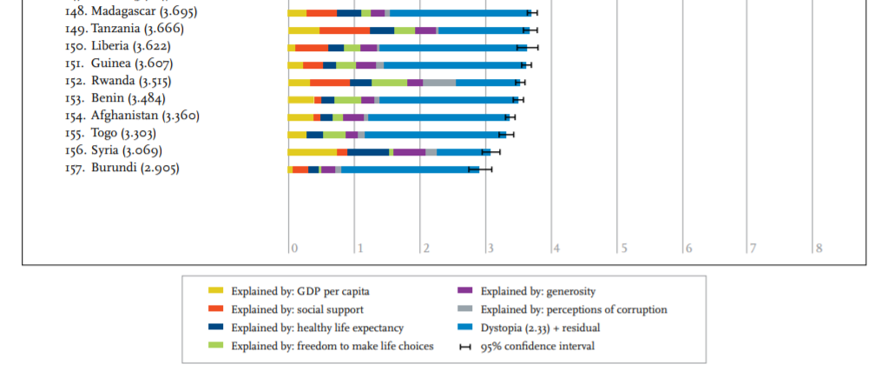

### 2017:

**Top 10[7]:**

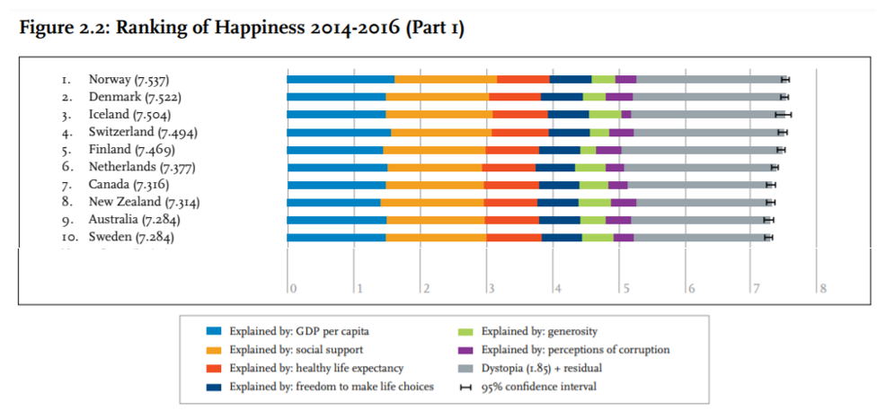

**Bottom 10[8]:**

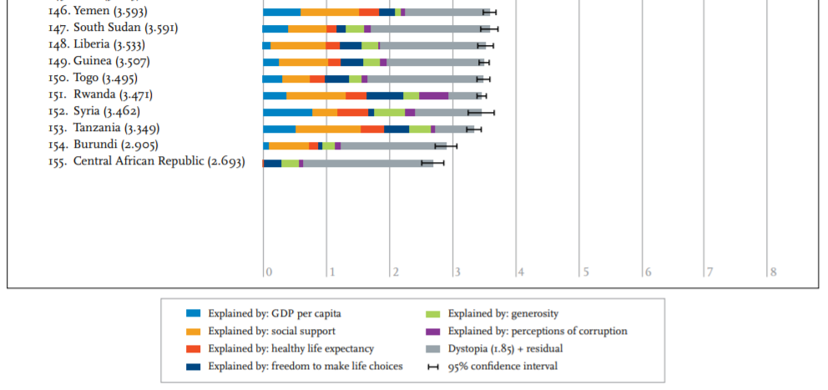

## Data used in Rstudio

**###2013 data**

##2013 top 10 happiest countries:

#1 Denmark - row 13482

#2 Norway - row 37151

#3 Switzerland - row 48660

#4 Netherlands- row 34715

#5 Sweden – row 48401

#6 Canada - row 8924

#7 Finland - row 17431

#8 Austria - row 3273

#9 Iceland - row 22516

#10 Australia – row 3014

##2013 top 10 unhappiest countries:

#1 Senegal - row 43789

#2 Syria - row 48919

#3 Comoros - row 11025

#4 Guinea - row 20589

#5 Tanzania – row 49696

#6 Rwanda - row 41440

#7 Burundi – row 8147

#8 Central African Republic - row 9516

#9 Benin – row 5598

#10 Togo - row 50473

**###2015 data**

##2015 top 10 happiest countries:

#1 Switzerland – row 48662

#2 Iceland – row 22518

#3 Denmark - row 13484

#4 Norway - row 37153

#5 Canada - row 8926

#6 Finland - row 17433

#7 Netherlands - row 34717

#8 Sweden - row 48403

#9 New Zealand - row 35160

#10 Australia - row 3016

##2015 top 10 unhappiest countries:

#1 Chad - row 9917

#2 Guinea - row 20591

#3 Ivory Coast - NA

#4 Burkina Faso - row 7890

#5 Afghanistan - row 27

#6 Rwanda – row 41442

#7 Benin - row 5600

#8 Syria - row 48921

#9 Burundi - row 8149

#10 Togo - row 50475

**###2016 data**

##2016 top 10 happiest countries:

#1 Denmark - row 13485

#2 Switzerland - row 48663

#3 Iceland – row 22519

#4 Norway - row 37154

#5 Finland - row 17434

#6 Canada – row 8927

#7 Netherlands - row 34718

#8 New Zealand - row 35161

#9 Australia - row 3017

#10 Sweden - row 48404

##2016 top 10 unhappiest countries:

#1 Madagascar – row 29179

#2 Tanzania – row 49699

#3 Liberia - row 27756

#4 Guinea – row 20592

#5 Rwanda - row 41443

#6 Benin - row 5601

#7 Afghanistan – row 28

#8 Togo – row 50476

#9 Syria - row 48922

#10 Burundi- row 8150

**###2017 data**

##2017 top 10 happiest countries:

#1 Norway - row 37155

#2 Denmark - row 13486

#3 Iceland - row 22520

#4 Switzerland - row 48664

#5 Finland - row 17435

#6 Netherlands - row 34719

#7 Canada - row 8928

#8 New Zealand - row 35162

#9 Australia - row 3018

#10 Sweden - row 48405

##2017 top 10 unhappiest countries:

#1 Central African Republic - row 9520

#2 Burundi - row 8151

#3 Tanzania - row 49700

#4 Syria - row 48923

#5 Rwanda - row 41444

#6 Togo - row 50477

#7 Guinea - row 20593

#8 Liberia - row 27757

#9 South Sudan - row 46954

#10 Yemen - row 55875

1. P. 23
2. P. 25
3. P. 16
4. P. 18
5. P. 22
6. P. 24
7. P. 22
8. P. 24